INTRODUCTION:

Airline safety has consistently been a primary concern for airlines. To evaluate aviation safety and fatalities data, datasets from the Aviation Safety Network (airline safety) and airplane crashes from Kaggle were utilized. This assessment was conducted to obtain metrics on airline safety.

VISUALIZATIONS:

To represent statistics based on various factors, I utilized bar charts in my visualizations. Additionally, I used a Geolocation chart to provide a visual representation of the countries with higher fatality rates and line charts to demonstrate the trends in airline fatalities. In all the visualizations, I opted to use shades of red to indicate incidents or fatalities.

PRESENTATION PLAN:

I intend to showcase statistics on airline fatalities during the presentations, which will assist management in identifying problematic areas and implementing safety measures. Additionally, they can compare various airlines and aircraft based on the data. The aim is to provide insights into the most critical aspects so that management can make accurate decisions when communicating with the media.

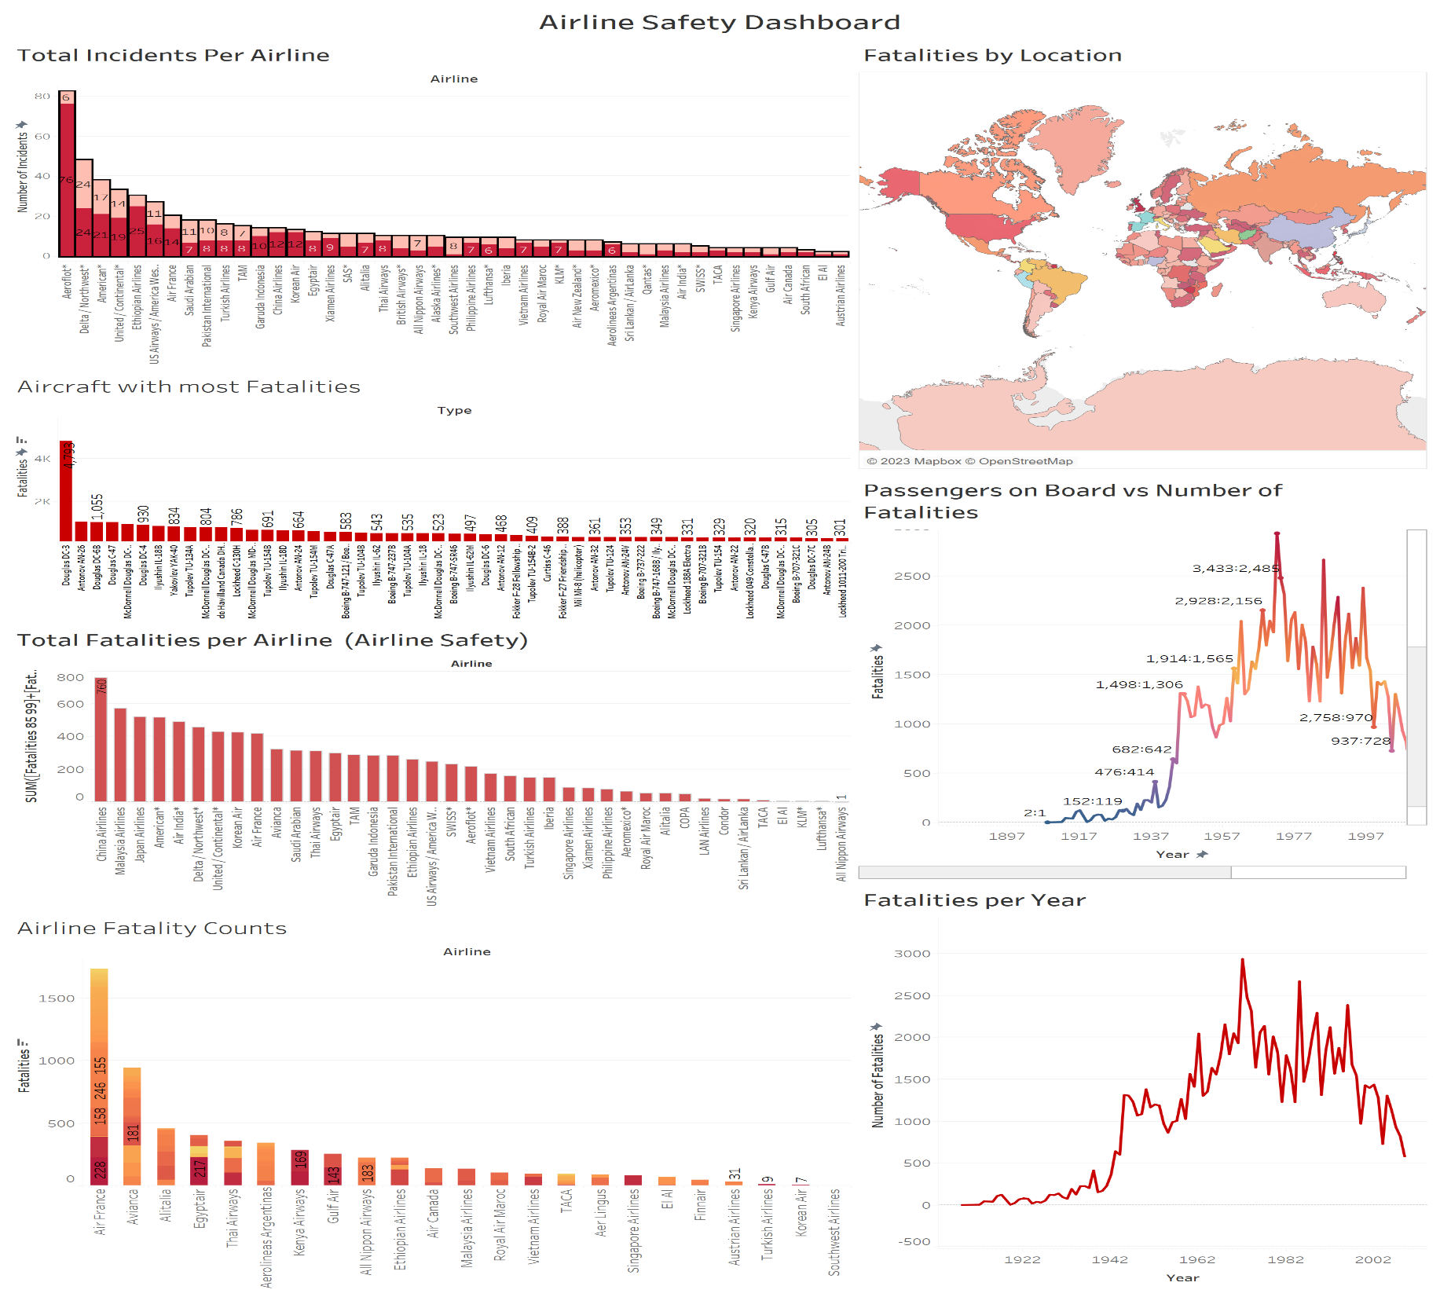

The above dashboard on Airline Fatalities was generated using Tableau. The primary goal of the dashboard is to provide insights to the management on airline fatality and incident statistics and give recommendations on problem areas.

FINDINGS:

1. Airline Incidents Per Airline: This visualization presents data from the Airline Safety dataset, showcasing the total number of incidents reported. By examining the stacked bar chart, Aeroflot\* was responsible for most incidents.

Recommendation: It would be beneficial to conduct a thorough analysis of the incidents and identify potential safety measures to prevent similar incidents from occurring again in the future.

1. Aircraft with the most Fatalities: The bar chart represents the number of fatalities by aircraft type. From the chart, it is evident that the Douglas DC-3 aircraft has the most fatalities with over 4000 fatalities.

Recommendation: A detailed analysis and inspection of the aircraft type should be undertaken to further analyze if this is truly an aircraft issue or if other factors such as weather/location contribute to the fatalities. If this happens to be an aircraft issue, airlines need to work with the aircraft manufacturer to ensure safety measures are established and the same needs to be communicated to all airlines.

1. Airline Safety – Bar chart on Total Fatalities per Airline: This bar chart displays the total number of reported fatalities in the Airline Safety data between 1985 and 2014. We can see from the chart, that China Airlines reported the highest number of fatalities at 760, followed by Malaysian Airlines and Japan Airlines. China Airlines accounted for about 8% of total fatalities during this period. The number of fatalities across the 57 airlines ranged from 1 to 760. It's worth noting that the figures from Airline Safety data differ from the airline crash data available on Kaggle (chart # 4).
2. Stacked Bar chart on Airline Fatality Counts: The objective of this chart is to determine which airline had the highest and lowest fatalities. Additionally, this visualization shows the number of fatalities per year, which allows us to compare the increase/decrease in fatalities across years. Looking at the chart, it is evident that Air France had the most fatalities.

Recommendation: Comparing the fatality statistics across airlines gives an idea of where we stand with safety measures and what necessary steps can be taken to improve.

1. Geolocation Map: This map displays data based on longitude and latitude coordinates. The varying shades of red indicate the number of fatalities at the country level. Most of the fatalities occur in the USA and Russia. One reason behind this could be the air traffic which is more in large countries in comparison to others. However, we cannot assume this to be a reason for more fatalities. Further investigation may be required to identify the reason behind these fatalities and implement necessary steps to ensure safety.
2. Line Chart – Passengers on board vs Number of fatalities: This line chart depicts the number of fatalities per year, with the number of passengers on board and the number of fatalities. This is to provide any insights into the effects of the number of passengers on board with the type of fatality.

Recommendations: One can conduct an analysis to determine the impact of passenger count and aircraft type, on airline safety and explore potential adjustments that may prevent crashes.

1. Line Chart – Fatalities per Year: This line chart depicts the number of fatalities per year, allowing us to observe trends over time. By analyzing the spikes in fatalities, we can identify potential reasons for the increase. We can see that the number of Fatalities started trending down in 1999, falling by 40.10% (389) in 10 years.﻿ The number of Fatalities dropped from 970 to 581 during its steepest decline between 1999 and 2009. Thanks to technological advancements and increased safety measures in air travel, the number of fatalities has significantly decreased.

ETHICAL IMPLICATIONS:

* + - 1. Ensuring data accuracy is crucial, especially when the data is obtained from a public website rather than an airline-specific or government one. It is difficult to ascertain the accuracy of such data. We can see a discrepancy between the Airline Safety data and the airline crash data provided on Kaggle, which brings into question the reliability of the data source.
      2. It's worth noting that the crash reports dataset only goes up until 2014, which is a decade ago. It would improve the accuracy of the analysis if more recent data were available.